**INT 217 Introduction to Data Management**

**An Excel Dashboard – Super Store Analysis**

Submitted By

**Rocky Sharaf**

**11918040 - RKM007B79  
 B. Tech - Computer Science and Engineering**

Under the Guidance of  
 **Sandeep Kaur – 23614  
 Discipline of CSE/IT   
 Lovely School of Computer Science and Engineering**

**   
   
 LOVELY PROFESSIONAL UNIVERSITY  
 PHAGWARA, PUNJAB**

**Certificate**This is to certify that **Rocky Sharaf** bearing Registration no. **11918040** has successfully completed **INT 217** (Introduction to Data Management) project titled, **“An Excel Dashboard – Super Store Analysis”** under my guidance and supervision. To the best of my knowledge, the present work is the result of his original development, effort, and study.

**Sandeep Kaur - 23614  
School of Computer Science and Engineering  
Lovely Professional University   
Phagwara, Punjab.**

**Date – 28 Nov 2021**

**Student Declaration**

I, **Rocky Sharaf**, **11918040** a student of **B.Tech Computer Science and Engineering** under CSE/IT Discipline at, **Lovely Professional University, Punjab**, hereby declare that all the information furnished in this project report is based on my own intensive work and is genuine.

  
**Rocky Sharaf  
11918040 - RKM007B79  
B. Tech - Computer Science and Engineering  
Lovely Professional University, Phagwara**

**Date - 28/11/2021**

**Acknowledgement**

The opportunity of attaining a course based on **Data Management using Excel** at **Lovely Professional University** was worth learning. It was a prestige for me to be part of it. During the period of my course, I received tremendous knowledge related to **Microsoft Excel** and **Data Management**.

Pre-eminently, I would like to express my deep gratitude and special thanks to my course teacher **Sandeep Kaur** for her theoretical knowledge and encouragement on this project and for her valuable guidance and affection for the successful completion of this project.

Secondly, I would like to thank **Lovely Professional University** for giving me an opportunity to learn this course.

Lastly, I would like to thank the almighty and my parents for their constant encouragement, moral support, personal attention, and care.

**Rocky Sharaf  
11918040 - RKM007B79  
B. Tech - Computer Science and Engineering  
Lovely Professional University, Phagwara**

**Date - 28/11/2021**

**Contents**

|  |  |  |
| --- | --- | --- |
| Sr. No. | Topic | Page No. |
| 1 | Cover Page | 1 |
| 2 | Certificate | 2 |
| 3 | Student Declaration | 3 |
| 4 | Acknowledgement | 4 |
| 5 | Contents | 5 |
| 6 | List of Tables and Figures | 6 |
| 6 | Abstract | 8 |
| 7 | Chapter 1 – Introduction | 9 |
| 8 | Chapter 2 – Objectives | 10 |
| 9 | Chapter 3 – Source of Dataset | 11 - 12 |
| 10 | Chapter 4 – ETL Process | 12 |
| 11 | 🡪 Extraction | 13-14 |
| 12 | 🡪 Transform | 15 |
| 13 | 🡪 Load | 15 |
| 14 | Chapter 5 – Data Analysis | 16-30 |
| 15 | Chapter 6 – Dashboard | 31-34 |
| 16 | 🡪 Special Features | 34-36 |
| 17 | Summary of Report | 37 |
| 18 | References | 38 |

**List of Tables and Figures**

|  |  |  |
| --- | --- | --- |
| Sr. No. | Table and Figure Name | Page No. |
| 3.1 | Raw Data Set | 12 |
| 4.1 | Raw Data from Kaggle | 13 |
| 4.2 | Importing CSV Data Sets | 14 |
| 4.3 | Loading to Connection | 14 |
| 4.4 | Transforming Data | 15 |
| 5.1 | Objective 1 - Pivot Table 1 | 16 |
| 5.2 | Objective 1 - Pivot Table 2 | 17 |
| 5.3 | Objective 1 - Pivot Table 3 | 17 |
| 5.4 | Objective 1 - Pivot Table 4 | 18 |
| 5.5 | Objective 1 Result | 19 |
| 5.6 | Objective 2 Pivot Table and Settings | 19 |
| 5.7 | Objective 2 Result | 20 |
| 5.8 | Objective 3 Pivot Table and Settings | 21 |
| 5.9 | Objective 3 Result | 21 |
| 5.10 | Objective 4 Pivot Table and Settings | 22 |
| 5.11 | Objective 4 Result | 22 |
| 5.12 | Objective 5 Pivot Table and Settings | 23 |
| 5.13 | Objective 5 Result | 24 |
| 5.14 | Objective 6 Pivot Table and Settings | 26 |
| 5.15 | Objective 6 Result | 27 |
| 5.16 | Objective 7 Pivot Table and Settings | 28 |

|  |  |  |
| --- | --- | --- |
| 5.17 | Objective 7 Pivot Table and Settings | 28 |
| 5.18 | Objective 7 Result | 29 |
| 5.19 | Objective 7 VLOOKUP | 29 |
| 5.20 | Objective 8 VLOOKUP | 30 |

**Abstract**Excel is a software program created by Microsoft that uses spreadsheets to organize numbers and data with formulas and functions. Excel analysis is ubiquitous around the world and used by businesses of all sizes to perform data analysis. Excel features calculation, graphing tools, pivot tables, and a macro programming language called Visual Basic for Applications, and several other features which make Excel a perfect choice to manage and analyze data. My project is an Excel Dashboard. The Excel Dashboard is used to display overviews of large data tracks. Excel Dashboards use dashboard elements like tables, charts, and gauges to show the overviews. The dashboards ease the decision-making process by showing the vital parts of the data in the same window. In this report, I have shared a project where I have done data analysis of an SuperStore data set. This report also presents my learning during my course classes.

**Chapter 1 - Introduction**

I have created an **Excel dashboard** of a **SuperStore data set**. This dashboard explains and highlights important Purchases, records, and trends in the SuperStore of United Stated.

The data set used contains information regarding all the previous Ships, Orders details, Products of stores and their Id’s. It includes information regarding all the Products that are sold in 2014-2017, The data set contains details of Approx. **9994** products and 21 columns which are : Row ID, Order ID, Order Date, Year, Month, Day, Ship Mode, Customer ID, Customer Name, Segment, Country, City, State, Postal Code, Region, Product ID, Category, Sub-Category, Product Name, Sales, Quantity , Discount, Profit.

I have **scrubbed** and **organized** the entire data set and performed the analysis of a clean data set. I have **deduced** and **calculated** important results from the data set with the help of various Excel features like **pivot tables** and **functions** and represented them in the form of a **dynamic dashboard** using excel visualizing tools and various charts.

**Chapter 2 - Objectives**

Online shopping has grown in popularity over the years, mainly because people find it convenient and easy to bargain shop from the comfort of their home or office.

One of the most enticing factor about online shopping, particularly during a holiday season, is it alleviates the need to wait in long lines or search from store to store for a particular item.

However, here are the few main objectives that are discussed in the dashboard.

* Calculation of Sales and profit with respect to Sub-Categories.
* Distribution of Top-10 products with region-wise count of Sub-categories Items.
* Top-10 Customers who benefitted the store versus those customers who ordered frequently.
* Customer Level Analysis On the basis of Segments.
* State wise Calculation of Profit in the super store of US.
* Calculation of sales per year in percentage in whole timeline.
* Yearly/ Monthly Profit Earned with respect to Sales.
* Calculation of customer id with respect to Order id.
* Calculation of customer name with respect to Order id.

**Chapter 3 - Source of Dataset**

The dataset is taken from **Kaggle**. Kaggle is a community of data scientists and data enthusiasts. This platform allows users to find and publish data sets.  
I have selected a Super Store data set which contains important details of 4 years of store History.  
Here are the details of my chosen data set.

**Name –** Super Store Analysis  
**Link -**<https://www.kaggle.com/juhi1994/superstore>  
**Author –** juhi1994  
**Format –** XLS  
**No. of Data Sets** – 1  
**Size –** 3.35 MB

**No. of Rows –** 9994   
**No. of Columns –** 21

**Data Set 1: Data Fields**

* Row ID integer
* Order ID object
* Order Date datetime
* Ship Mode object
* Customer ID object
* Customer Name object
* Segment object
* Country object
* City object
* State object
* Postal Code integer
* Region object
* Product ID object
* Category object
* Sub-Category object
* Product Name object
* Sales float
* Quantity integer
* Discount float
* Profit float

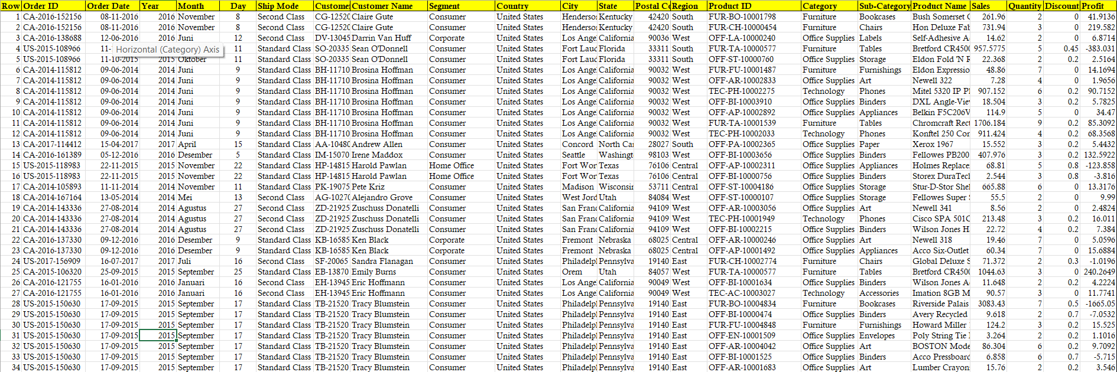 **Table 3.1 – Raw Data Set**

**Chapter 4 - ETL Process**

In computing, extract, transform, load (ETL) is a process to prepare data for analysis, especially in data warehousing. Data extraction involves extracting data from homogeneous or heterogeneous sources, while data transformation processes data by transforming them into a proper storage format/structure for the purposes of querying and analysis; finally, data loading describes the insertion of data into the final target location such as an operational data store, a data mart, or a data warehouse. A properly designed ETL system extracts data from the source systems, enforces data quality and consistency standards, conforms data so that separate sources can be used together, and finally delivers data in a presentation-ready format so that application developers can build applications and end users can make decisions.  
I have also performed many steps in the ETL process to prepare my data for analysis:

**Extraction**

The raw data has been taken from Kaggle, before processing the data it looked like this

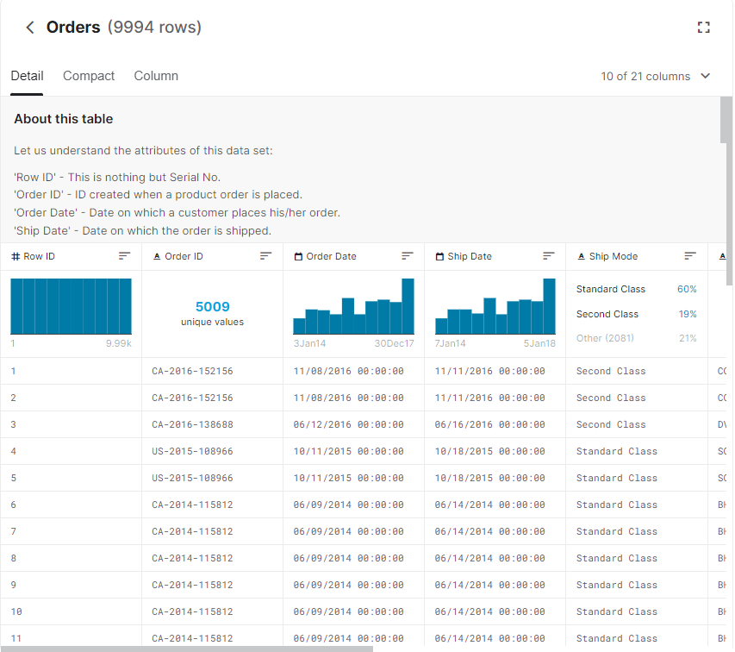 **Table 4.1 – Raw Data from Kaggle**

The data can be imported into excel directly from the web using get data features, but I have first downloaded the XLS files manually from excel then imported it into excel using the get data feature.

**Step 1** – Open a new excel workbook.

**Step 2** – Use the **Get Data** feature.

**Table 4.2 – Importing CSV Data Sets**

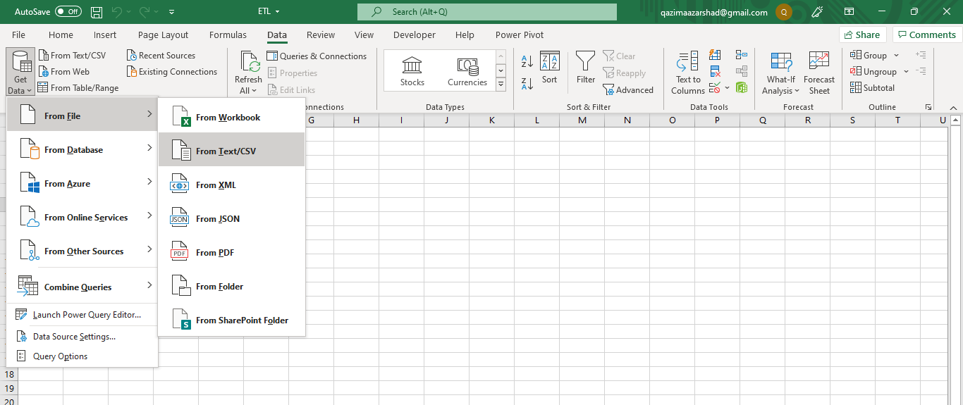

**Step 3** – Load to **Connection**

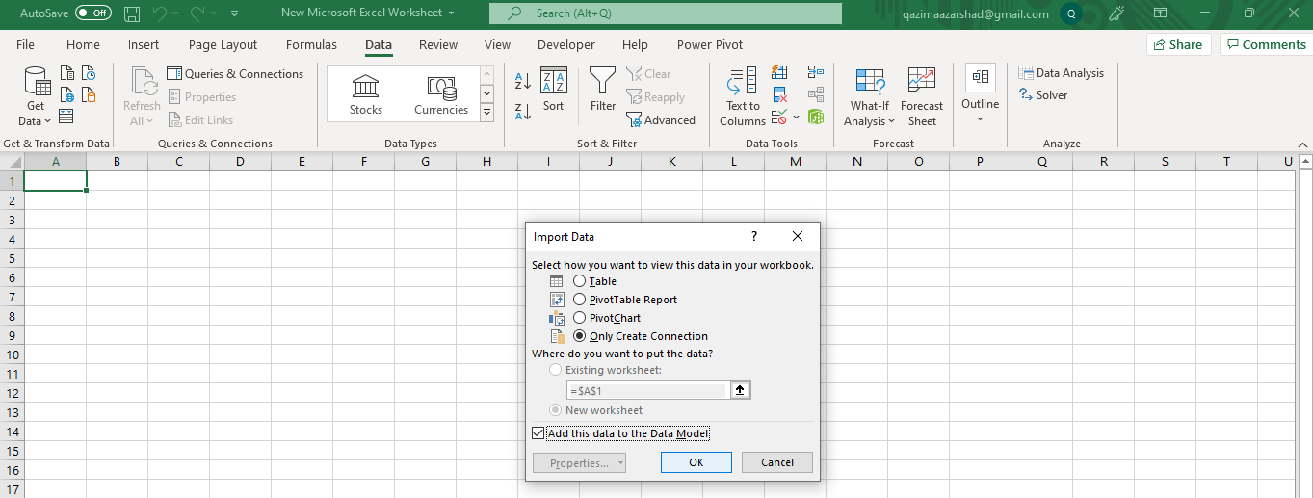 **Table 4.3 – Loading to Connection**

**Step 4** – Repeat the process for all the data sets. In my case there were only two data sets.  
Now that we have extracted the data from the source and have imported it, now is the time to transform the data.

**Transform**

If we want to transform the data before loading it can be done. Although transformation can be done even after loading the data, but it is better to first process the data before loading.

**Step 1** – Use Get Data feature. But instead of loading to connection, click on **transform**.

**Step 2** – Remove the unwanted rows or column or modify the data in   
**Power Query Editor**.

Now I have removed the unwanted column in the data set.

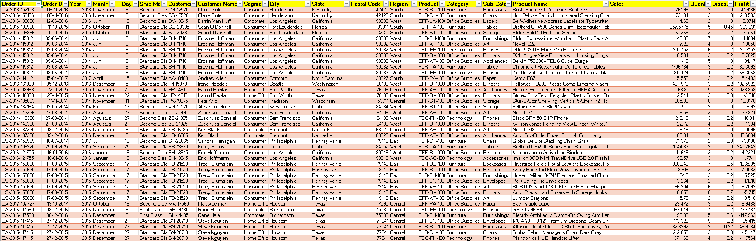 **Table 4.4 – Table After Transforming in Power Query Editor**

Now after we had imported and transformed all the data sets it will look like this

**Chapter 5 - Data Analysis**

**Objective 1 – Calculation of Sales and profit with respect to Sub-Categories.**

**Description –** The objective is to calculate the profit and sales from the categories columns which are further divided into sub categories

**Requirements –**

* Pivot Tables
* Divide (/) and Subtract (-) Formula, Get Pivot Data Formula
* Doughnut Charts (Customized Pie Chart + Text Box)
* Many Slicers

**Specifications -**

* Pivot Table 1 – To count sub-categories

**Table 5.1 – Objective 1 - Pivot Table 1**

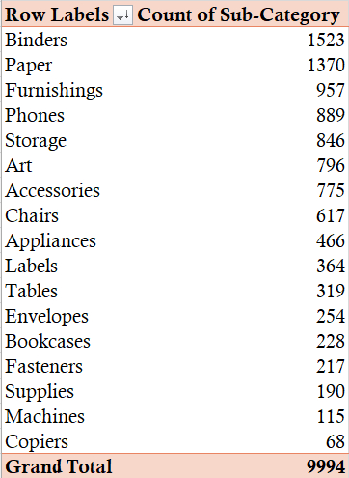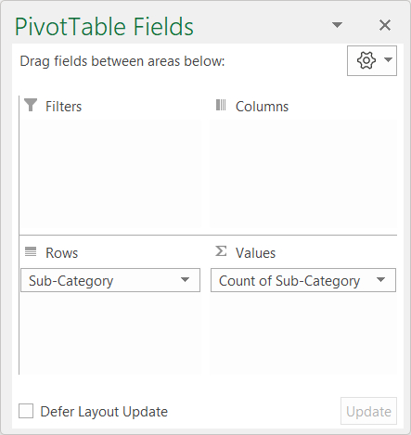

* Pivot Table 2 – To count total profit and sales as per sub-categories.

**Table 5.2 – Objective 1 - Pivot Table 2**

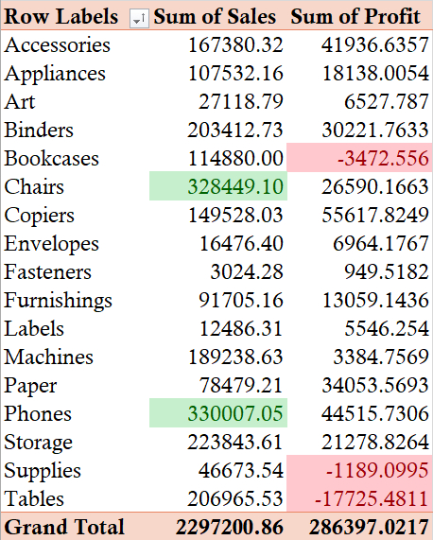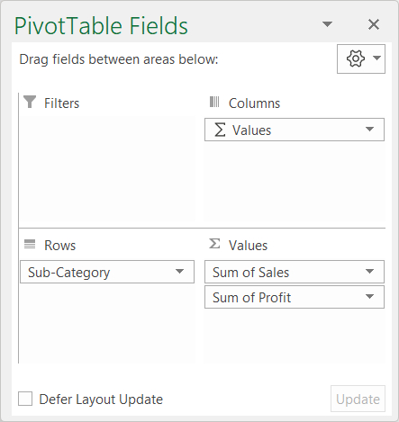

**Result and Visualization –**

**Table 5.3 – Objective 1 Result**

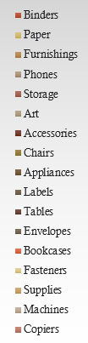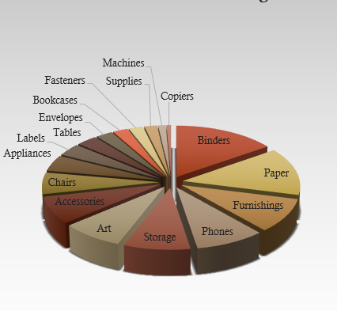

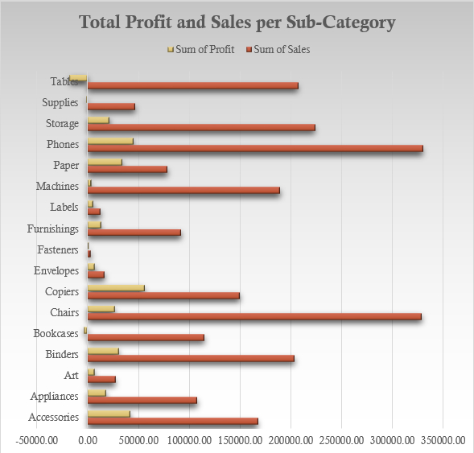

* **Objective 2 – Distribution of Top-10 products with region-wise count of Sub-categories Items.**

**Description –** The objective is to display the products which are sold at high quantity in relation to sub-categories and region-wise

**Requirements –**

* Pivot Table
* Pivot Chart
* Many Slicers

**Table 5.4 – Objective 2 Pivot Table and Settings**

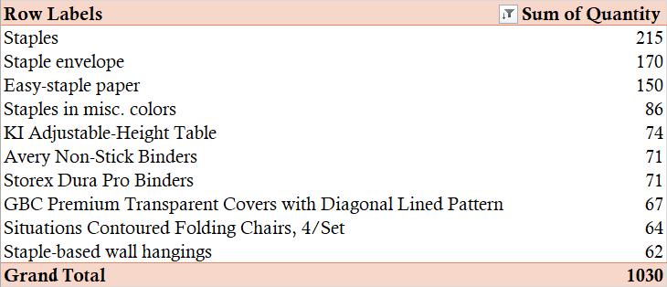

**Result and Visualization –**

**Table 5.5 – Objective 2 Result**

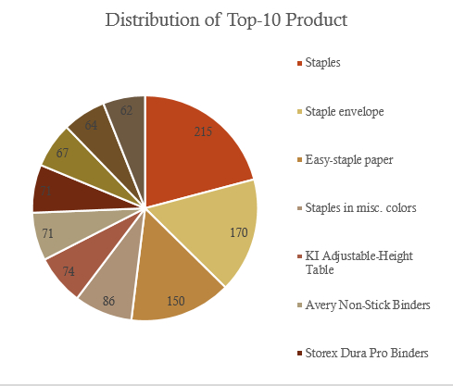

**Table 5.6 – Objective 2 Pivot Table and Settings**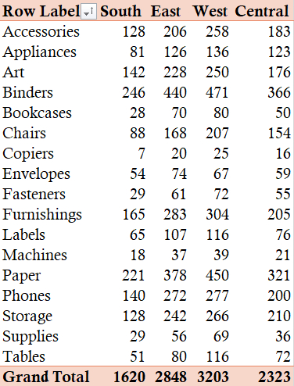

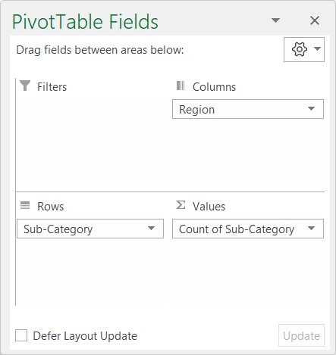

**Result and Visualization –**

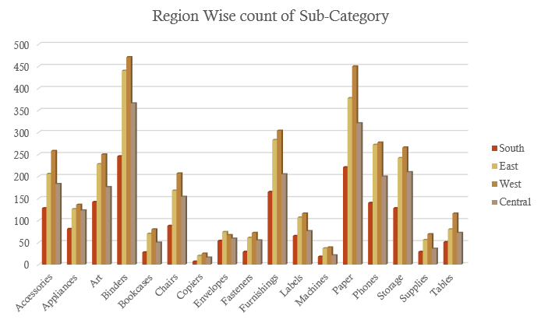 **Table 5.7 – Objective 2 Result**

**Objective 3 – Top-10 Customers who benefitted the store versus those customers who ordered frequently.**

**Description –** The objective is to display the list of customer who ordered frequently plus those who benefitted the store.

**Requirements –**

* Pivot Table
* Pivot Chart
* Many Slicers

**Table 5.8 – Objective 3 Pivot Table and Settings**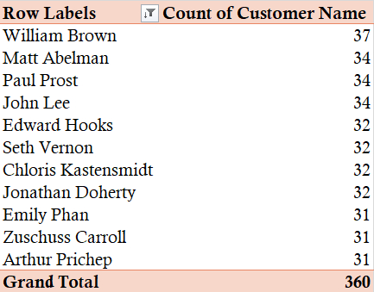

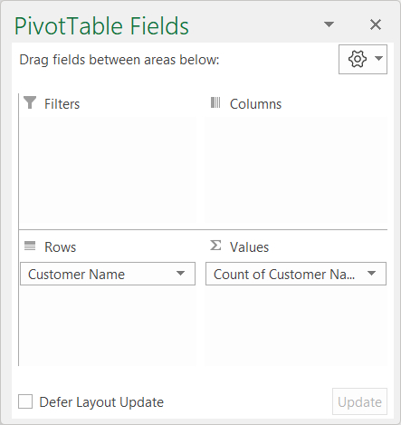

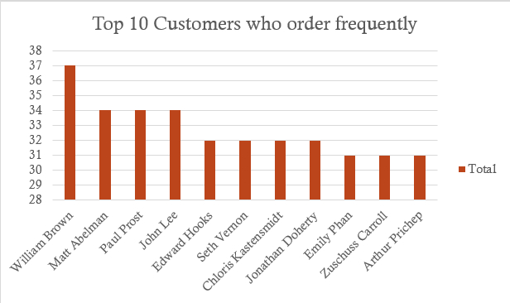**Result:**

**Table 5.9 – Objective 3 Pivot Table and Settings**

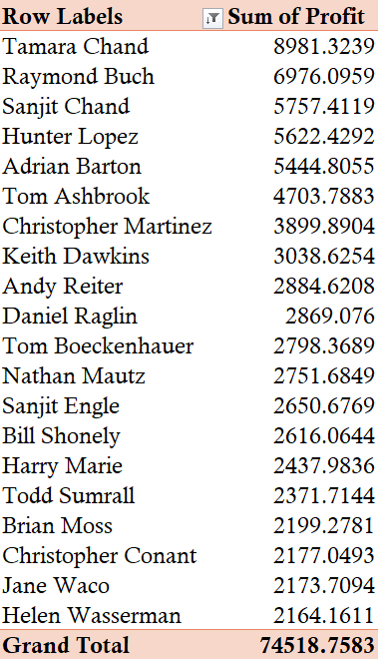

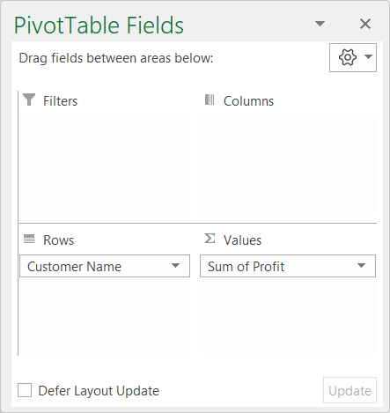

**Result and Visualization –**

**Table 5.10 – Objective 3 Result**

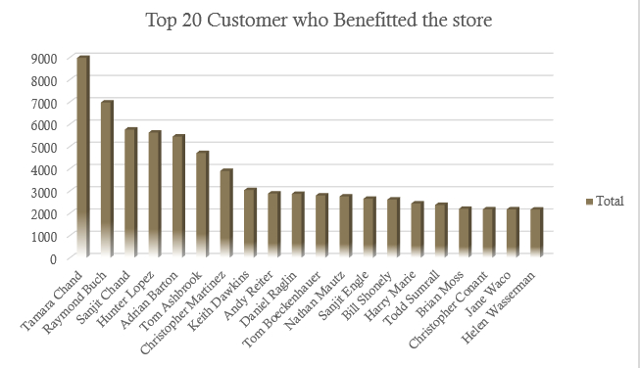



**Objective 4 – Customer Level Analysis On the basis of Segments.**

* **Description –** The objective is to display the Customer Level Analysis On the basis of Segments.

**Requirements –**

* Pivot Table
* Pivot Chart
* Many Slicers

**Table 5.11 – Objective 4 Pivot Table and Settings**

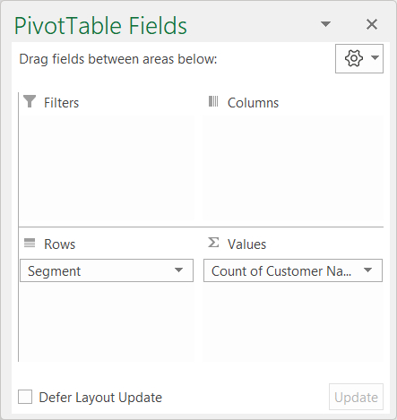  
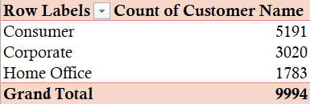

**Result and Visualization –**

**Table 5.12 – Objective 4 Result**

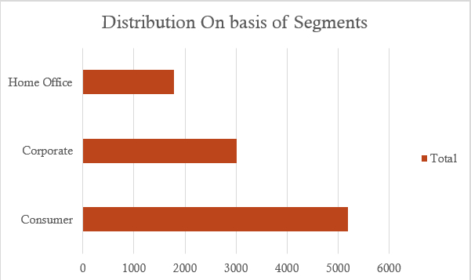

* **Objective 5 – State wise Calculation of Profit in the super store of US.**

**Description –** The objective is to display State wise Calculation of Profit in the super store of US.

**Requirements –**

* Pivot Table
* Pivot Chart
* Many Slicers

**Table 5.13 – Objective 5 Pivot Table and Settings**

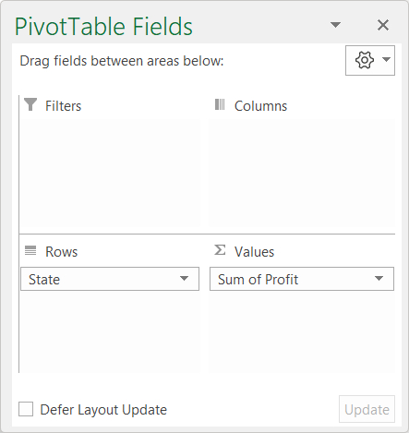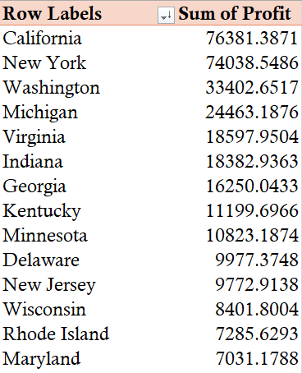

**Result and Visualization –**

**Table 5.14 – Objective 5 Result**

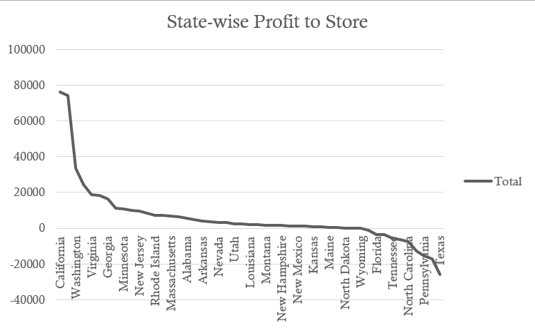

* **Objective 6 – Calculation of sales per year in percentage in whole timeline.**
* **Description –** The objective is to displayCalculation of sales per year in percentage in whole timeline.

**Requirements –**

* Pivot Table
* Pivot Chart
* Many Slicers

**Table 5.15 – Objective 6 Pivot Table and Settings**

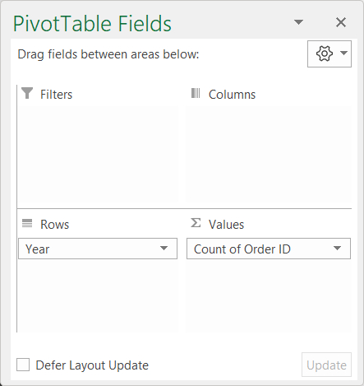

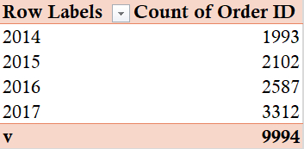

**Result and Visualization –**

**Table 5.16 – Objective 6 Result**

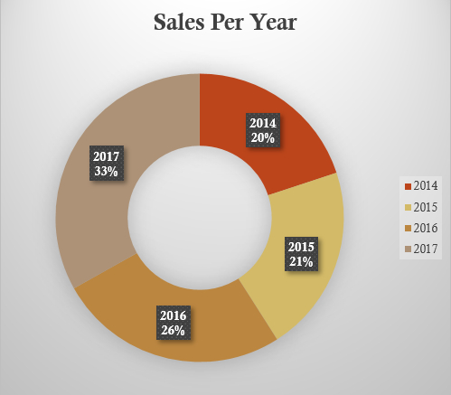

* **Objective 7 – Yearly/ Monthly Profit Earned with respect to Sales.**
* **Description –** The objective is to displayYearly/ Monthly Profit Earned with respect to Sales.

**Requirements –**

* Pivot Table
* Pivot Chart
* Many Slicers

**Table 5.17 – Objective 7 Pivot Table and Settings**

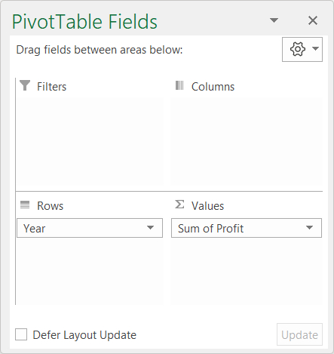

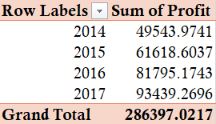

**Result and Visualization –**

**Table 5.18 – Objective 7 Result**

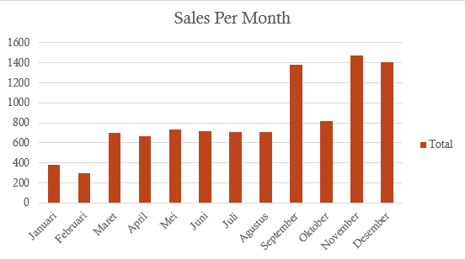

**Table 5.19 – Objective 7 Result**

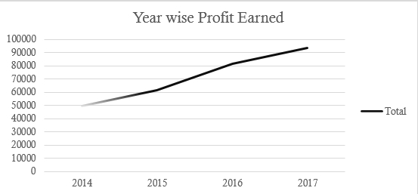

**Objective 8 –** **Calculation of customer id with respect to Order id.**

* **Description –** The objective is to display Calculation of customer id with respect to Order id.

**Requirements –**

* Dataset
* Data Validation
* General formula

**Table 5.20 – Objective 8 Result**

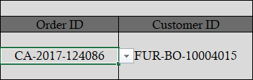

**Objective 6 – Calculation of customer name with respect to Order id.**

* **Description –** The objective is to display Calculation of customer name with respect to Order id.

**Requirements –**

* Dataset
* Data Validation
* General formula

**Table 5.21 – Objective 8 Result**

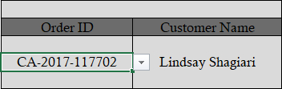

**Chapter 6 – Dashboard**

**Figure 6.1 – The Dashboard – D1**

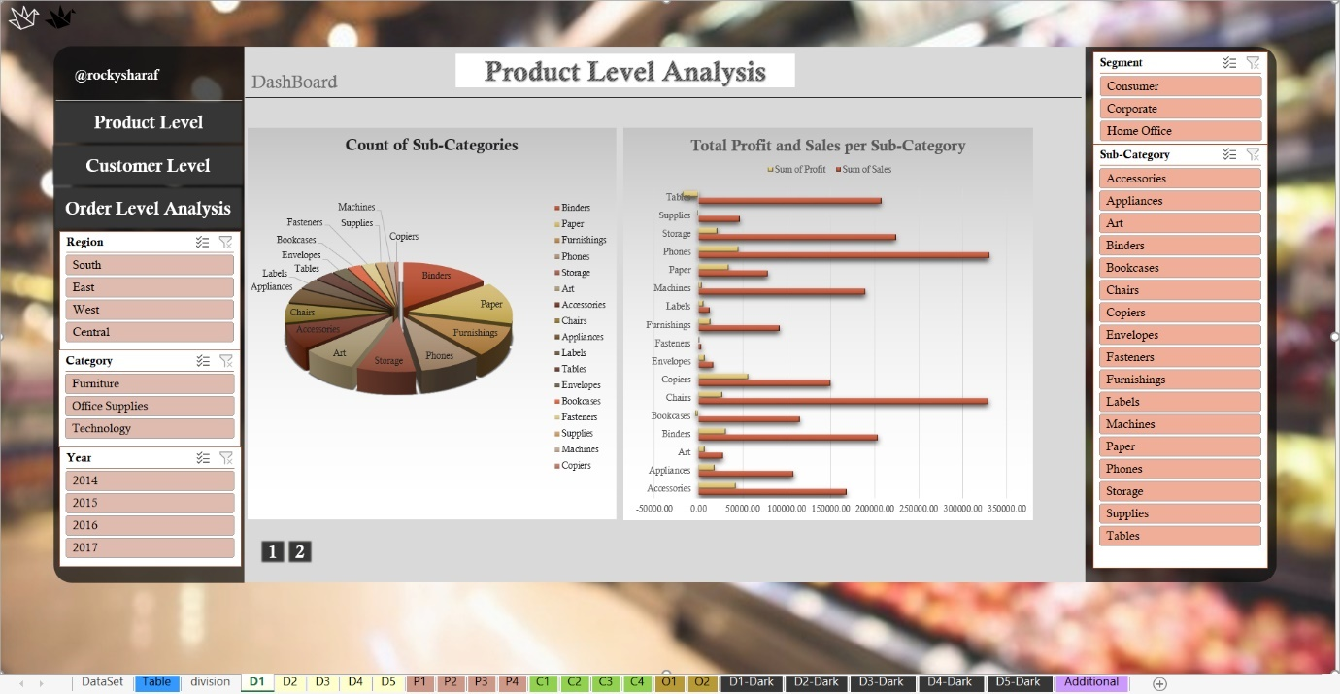  
  
 **Figure 6.1 – The Dashboard – D2**

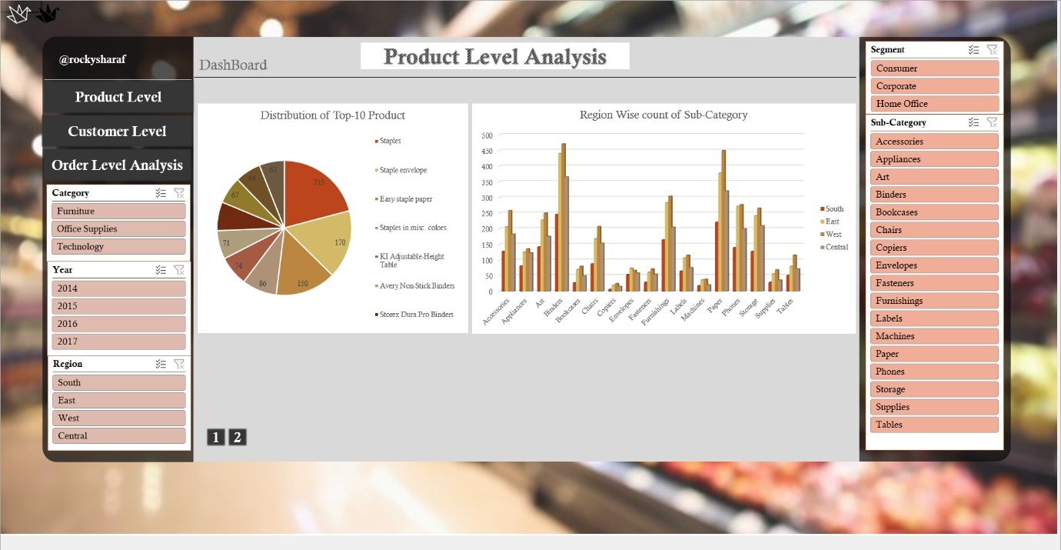

**Figure 6.1 – The Dashboard – D3**

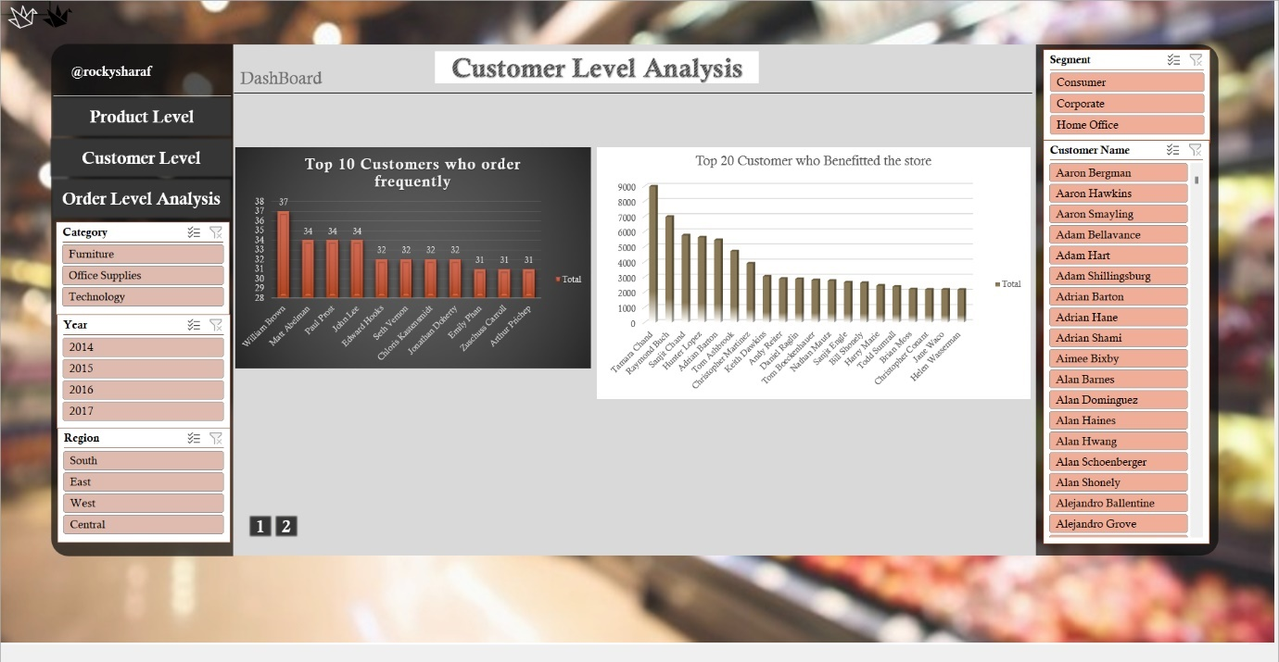

**Figure 6.1 – The Dashboard – D4**

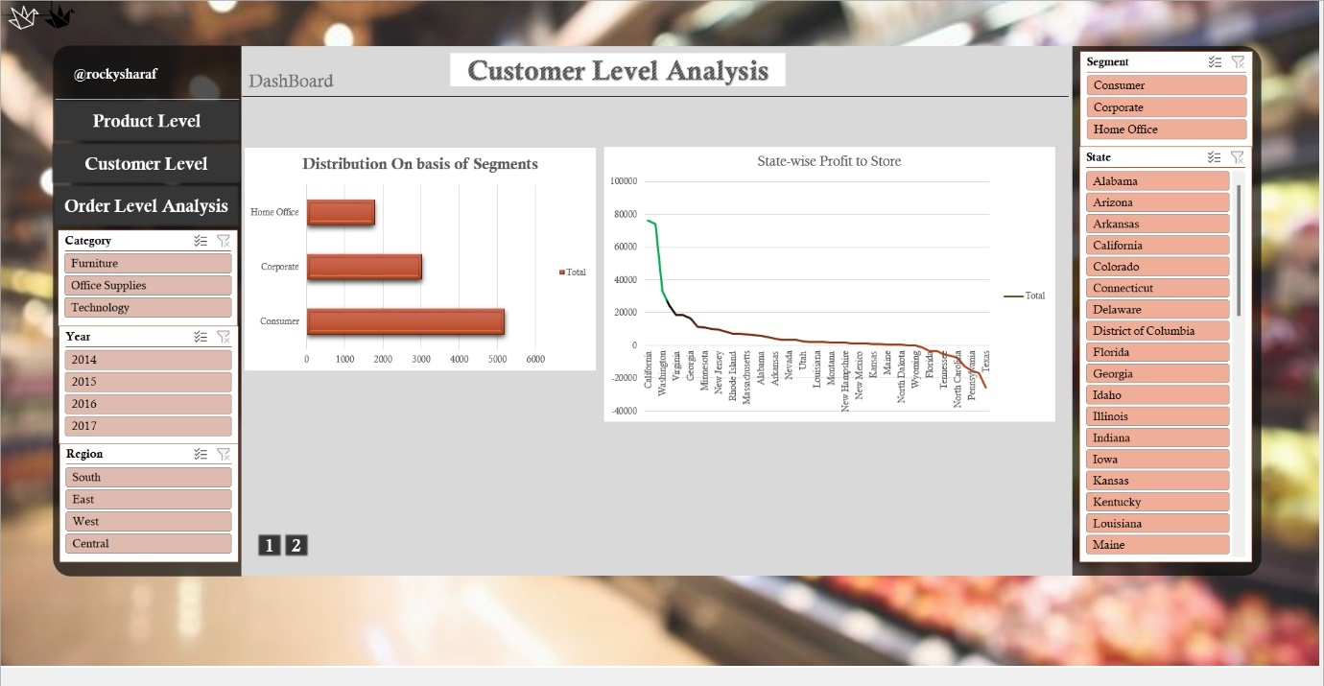

**Figure 6.1 – The Dashboard – D5**

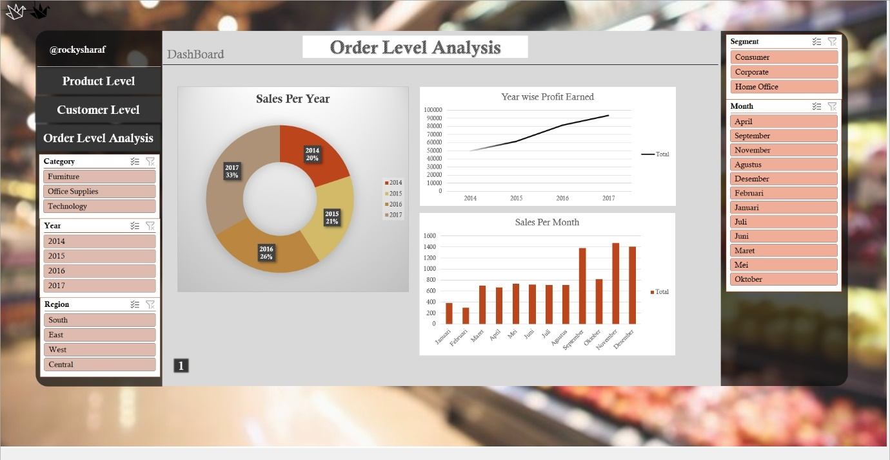

I have created this dashboard by combining all the results obtained in the data analysis, then connecting the required slicers, adding images, objects, and style to the dashboard.

This dashboard can be used to analyze super store in 3 different ways:

* Product Level Analysis
* Customer Level Analysis
* Order Level Analysis

*Which product is mostly sold by super store.  
Which product is giving loss, or which is giving profit to store.  
In which region, which product is mostly sold.  
Which sub-category is on trending from Furniture or Tech.  
Who visited the store most frequently?  
Whether the person who visit store frequently gives most profit?  
Who give most profit to store?  
The person who is spending most, is he giving more profit?  
Which state is more frequently visiting the superstore*  
etc. and a lot more data can be easily deduced from this dashboard, and not only just number but the result will be graphically represented.

This dashboard comes with some special features as well.

**Special Features**

This dashboard has many special features some are hidden, and some are visible. Important features are:  
**Dark/Light theme switch** – This switch allows user to change the theme color of the dashboard from white to black (light to dark).  
Excel does not provide such features; this switch has been added with a trick. This **switch** is just an **Image**, and this image is **linked to another copy of this dashboard** which has all charts with **dark.**

**Figure 6.2 – Dark/Light Toggle Switch**



**Light Mode Dark Mode**

**Figure 6.3 – Dark/Light Theme**

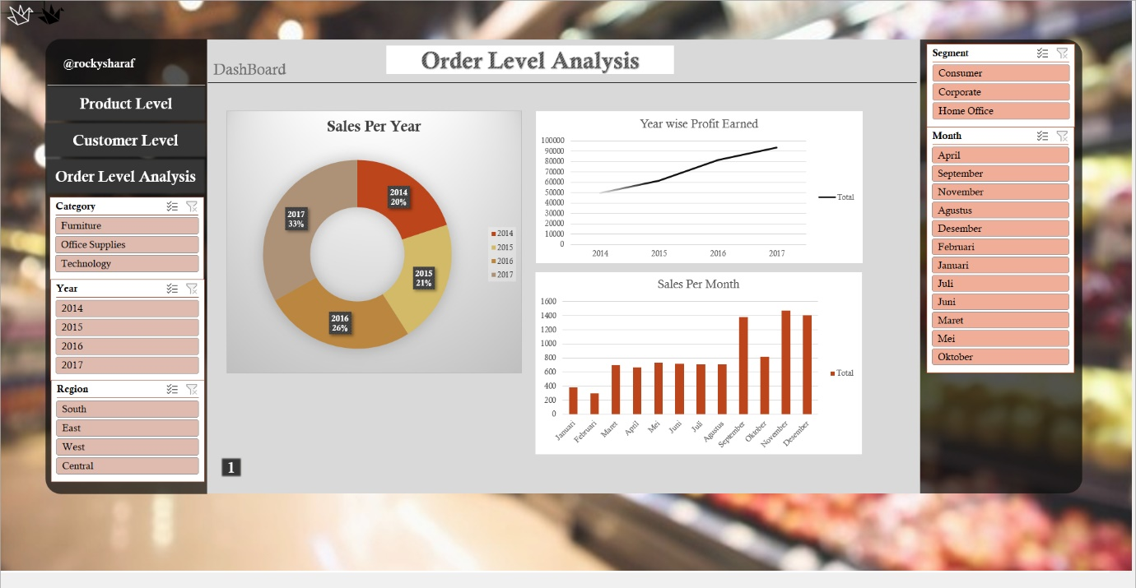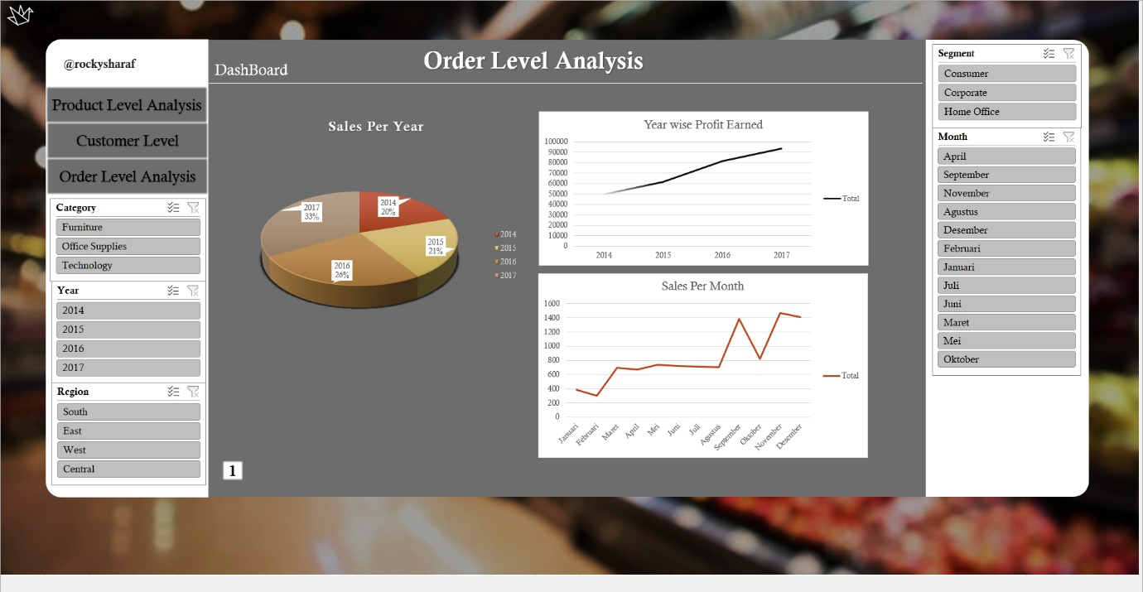

**Hidden Links and Master Sheet –** The dashboard has many hidden links which takes user directly to the source data and source pivot table which helps to understand the architecture of specific parts of the dashboard.

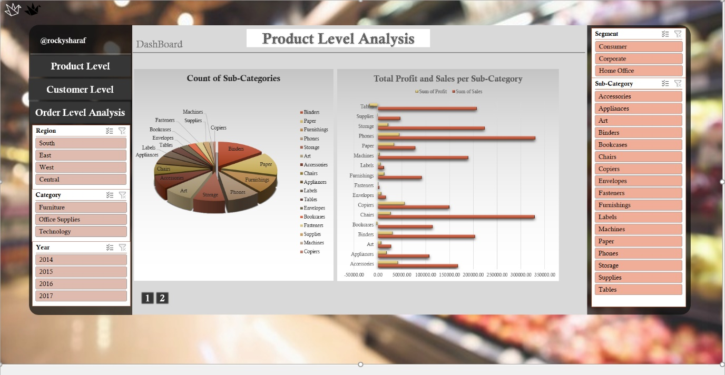**Figure 6.4 – Hidden Links**

Also every single sheet also has shortcut links which takes directly to dashboard and **Master Sheet**.

**Figure 6.5 – Shortcut Links to Dashboard and Master Sheet**

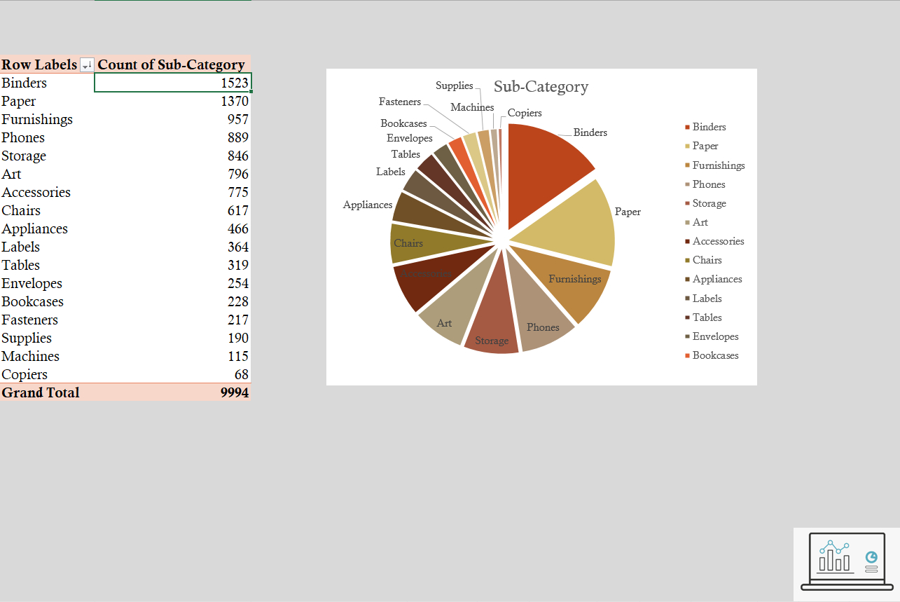

Back to Dashboard

**Summary of Report**

In this report I have discussed in detail my project, its working, making, features, and applications. I have explained each step of making a Superstore Statistics Dashboard using from a raw data using Excel.

This report highlights all the processes involved in the making in serial order from ETL processes extracting, transforming, and loading data to using several excel features like pivot table, filtering, sorting, formulas to perform data analysis and deduce important results then representing them graphically using charts.

I have also attached the preview of the dashboard, and all the objectives in this report.

**References**

* Super-Store Analysis: <https://www.kaggle.com/juhi1994/superstore>
* Excel documentation [: https://support.microsoft.com/en-us/excel](:%20https:/support.microsoft.com/en-us/excel)